***Testing Document***

Alborz Gharabaghi 216442428

Tariq Qureshey 216789166

Kamal Patel 216280224

**Table of Contents…………………………………………………………………………....**

**1 INTRODUCTION**

**2 OBJECTIVES AND TASKS**

**2.1 OBJECTIVES**

**2.2 TASKS**

**3 TESTING STRATEGY**

**3.1 JUNIT TESTING**

**3.2 TEST COVERAGE**

**1.0 Introduction**

This Testing document will be regarding test cases within our software that perform crucial tasks to ensure the software runs smoothly. As well as showing the test coverage of our software.

**2.0 Objectives and Tasks**

**Objective:** We are testing our program with JUnit tests, these tests will ensure that our program runs as expected and the customer will be satisfied with the product.

**3.0 Testing Strategy**

Our testing strategy including creating a plethora of JUnit tests, covering the most important aspects of our software. These include checking if default fonts are used rather than selected ones, how many circles are being created based on the slider in the customize frame, and much more. Below, you will see various screenshots and explanations of how we tested our software

**3.1 JUnit Testing**

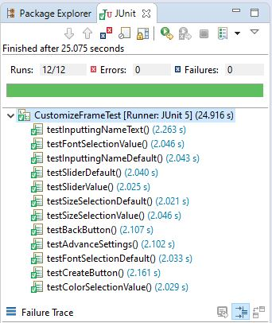

As you can see above, we tested our program with a plethora of methods. The tests above outline all the possible tests with the Customize frame of the program. These tests are sufficient as it tests the default values for the slider and all font selections. We derived these test cases by understanding all the possible ways the user might go about using our software. By keeping this in mind, we are able to be certain that our program runs the way it should when presented to the customer.

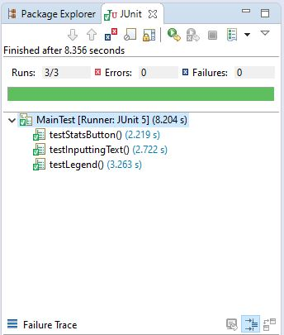

Here, the tests cover inside of the Venn diagram, including tests of the three most important components of it, the stats button, inputting data and testing the legend. These are sufficient as they cover the most important parts of the Venn diagram frame by testing if inputting data works, as well as if the stats button returns a proper breakdown of data.

**3.2 Test Coverage**

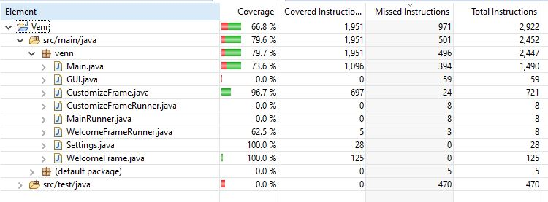

Here is an image of the test coverage for our system. It shows all of the classes in our program with percentages showing the coverages.